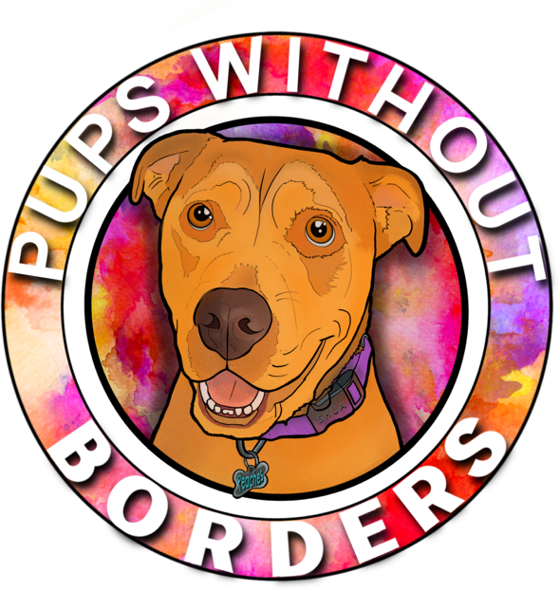
Pups Without Borders
14928 Bassett St
Van Nuys, CA 91405

213-513-7672

Animal Rescue in the US and Mexico

Tax ID 85-4373524

First Name:
Last Name:
Phone Number:
Email Address:
Street Address:
City and State:
Emergency Contact (for emergencies only)
Full Name:
Phone Number:
Email Address:
Do you have any experience with rescue dogs? For example, volunteering, fostering, etc:

Do you have any dog allergies?
Do you have a preference on your Pup’s...
Age?
Gender?
Size?
Personality?
Do you prefer a Pup that is physically active? Do you plan to take your Pup on walks or hikes?

Do you prefer to work with one dog, or a Mama dog and litter of puppies?

How long are you able to commit to being a Pupvocate?

*Ideally, a Pupvocate would work with their dog until that dog is adopted.
Why do you want to be a Pupvocate?

How did you hear about Pups Without Borders?

Please initial next to each clause to acknowledge that you agree to it:
_____ I understand that the dog I work with is the property of Pups Without Borders and I will not sell, trade, or dispose of the animal.
_____ I understand that anyone interested in adopting my assigned dog (including myself) must go through the standard adoption process, and that approval of candidates and adoption of animals is up to Pups Without Borders (though the rescue will try to accommodate such requests).
_____ I will never let the dog out off leash, or loose by itself.
_____ I will not let the dog interact with other people (especially children) or other animals, unless I have written permission from a representative of Pups Without Borders.
_____ While it is extremely unlikely, If the dog requires medical attention while we are together, I will contact Pups Without Borders first before taking the dog anywhere for any kind of treatment.
_____ I understand that all vet appointments must be approved by Pups Without Borders and I will NOT be reimbursed for any medical appointments made without the consent of a representative of the rescue. If the dog is experiencing a true life-threatening medical emergency, I must make reasonable attempts to contact Pups Without Borders for medical advice and guidance before going to an emergency vet.
_____ I understand that although Pups Without Borders takes reasonable care to screen dogs for the Pupvocate program, it makes no guarantee relating to the dog's health, behavior, or actions.
_____ I acknowledge that my involvement as a volunteer with Pups Without Borders entails known and possible risks (though incredibly unlikely) that could result in physical or emotional injury, including, but not limited to, bodily injury or property damage. I expressly agree and promise to accept and assume all the risks existing in such event and activities. My participation in such event and activities is purely voluntarily and I elect to participate notwithstanding such risks.
_____I release and discharge Pups Without Borders of and from any and all claims, demands, causes of action, and legal liability, whether the same be known or unknown, anticipated or unanticipated, due to Pups Without Border’s resulting from my participation in a Pups Without Borders event or activities, other than directly and solely resulting from Pups Without Borders gross negligence or willful misconduct. Further, I shall not bring any claim, demand, lawsuit, legal or administrative action against Pups Without Borders in respect of any of the foregoing. Should Pups Without Borders be required to incur attorneys’ fees, expenses, or other costs to enforce this Agreement, I agree to indemnify and hold Pups Without Borders harmless for all such fees, expenses or other costs.

